**COMP3900 Assignment Backend Instruction:**

1. **Download python for your computer:**
2. Download python fit for your computer system

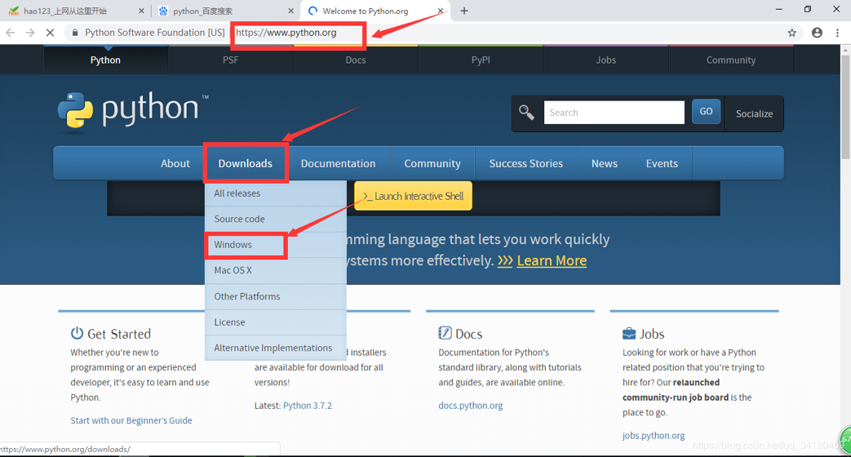

1. Choose “Customize install” cause we will use pip tools later.

1. Click all options (install some python packages automatically).

1. Press Install button to finish python install.

1. **Install virtualenv**
2. Move to ***capstone-project-dota_3900/backend*** with cmd.
3. Use “***pip3 install virtualenv***”to install virtualenv package.
4. Move to ***capstone-project-dota_3900/backend***with cmd, then run

“***virtualenv -p py3 venv***”to create a virtualenv with python3.

1. Move to ***capstone-project-dota_3900/backend/venv/Scripts*** with cmd.
2. Run “***activate***”to activate the virtualenv we have just created.
3. **Run backend api server**
4. Move to ***capstone-project-dota_3900/backend*** with cmd.
5. Run “***pip3 install -r requirement.txt***”to install all python packages needed for backend server. Make sure you already activated the virtualenv before this step.
6. Run “***python app.py***”to start the backend server.
7. By inputting the address “127.0.0.1:5000” in browser to move to user interface of backend server.

